1.

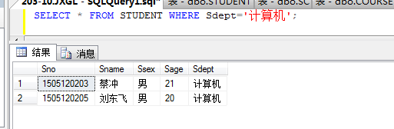

2.

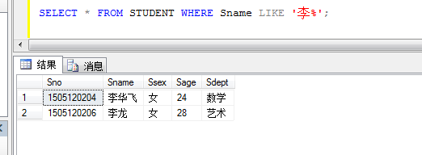

3.

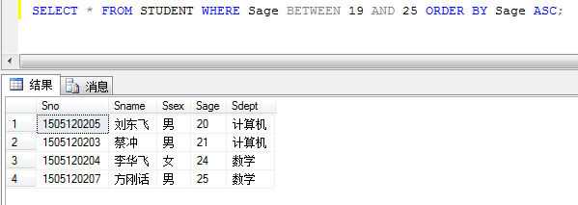

4.

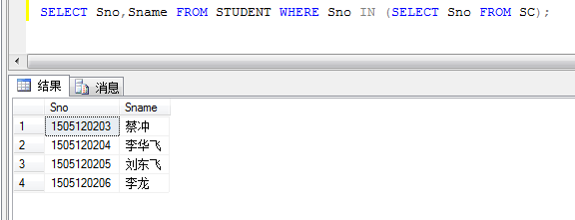

5.

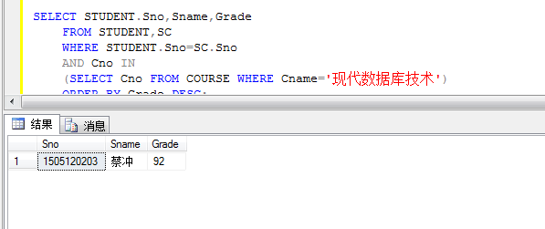

6.

SELECT * FROM STUDENT WHERE Sdept='计算机';

SELECT * FROM STUDENT WHERE Sname LIKE '李%';

SELECT * FROM STUDENT WHERE Sage BETWEEN 19 AND 25 ORDER BY Sage ASC;

SELECT Sno,Sname FROM STUDENT WHERE Sno IN (SELECT Sno FROM SC);

SELECT STUDENT.Sno,Sname,Grade

FROM STUDENT,SC

WHERE STUDENT.Sno=SC.Sno

AND Cno IN

(SELECT Cno FROM COURSE WHERE Cname='现代数据库技术')

ORDER BY Grade DESC;

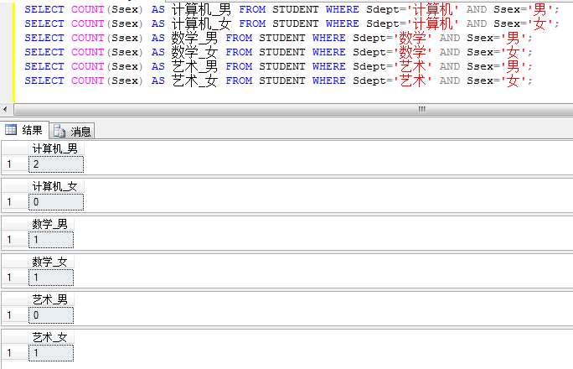

7.

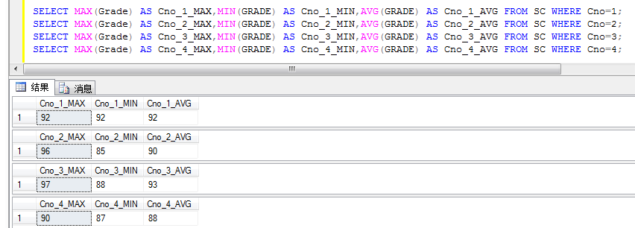

8.

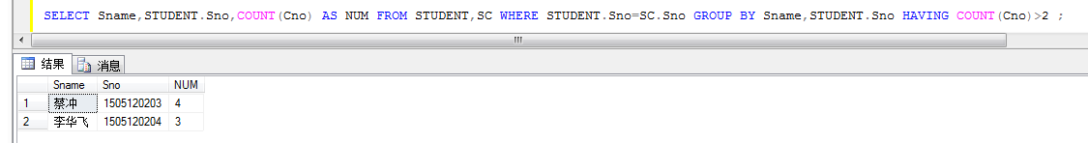

SELECT COUNT(Sdept) AS 计算机 FROM STUDENT WHERE Sdept='计算机';

SELECT COUNT(Sdept) AS 数学 FROM STUDENT WHERE Sdept='数学';

SELECT COUNT(Sdept) AS 艺术 FROM STUDENT WHERE Sdept='艺术';

SELECT MAX(Grade) AS Cno_1_MAX,MIN(GRADE) AS Cno_1_MIN,AVG(GRADE) AS Cno_1_AVG FROM SC WHERE Cno=1;

SELECT MAX(Grade) AS Cno_2_MAX,MIN(GRADE) AS Cno_2_MIN,AVG(GRADE) AS Cno_2_AVG FROM SC WHERE Cno=2;

SELECT MAX(Grade) AS Cno_3_MAX,MIN(GRADE) AS Cno_3_MIN,AVG(GRADE) AS Cno_3_AVG FROM SC WHERE Cno=3;

SELECT MAX(Grade) AS Cno_4_MAX,MIN(GRADE) AS Cno_4_MIN,AVG(GRADE) AS Cno_4_AVG FROM SC WHERE Cno=4;

SELECT Sname,STUDENT.Sno,COUNT(Cno) AS NUM FROM STUDENT,SC WHERE STUDENT.Sno=SC.Sno GROUP BY Sname,STUDENT.Sno HAVING COUNT(Cno)>2 ;

SELECT Cno FROM COURSE WHERE Cname='现代数据库技术' OR Cname='网络操作系统';

SELECT Sno FROM SC WHERE Cno IN (SELECT Cno FROM COURSE WHERE Cname='现代数据库技术') AND Cno IN (SELECT Cno FROM COURSE WHERE Cname='网络操作系统');

9.

10.

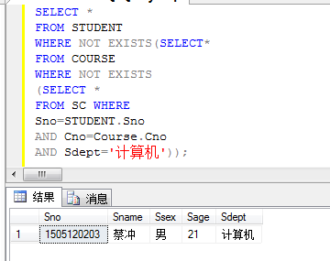

11.

